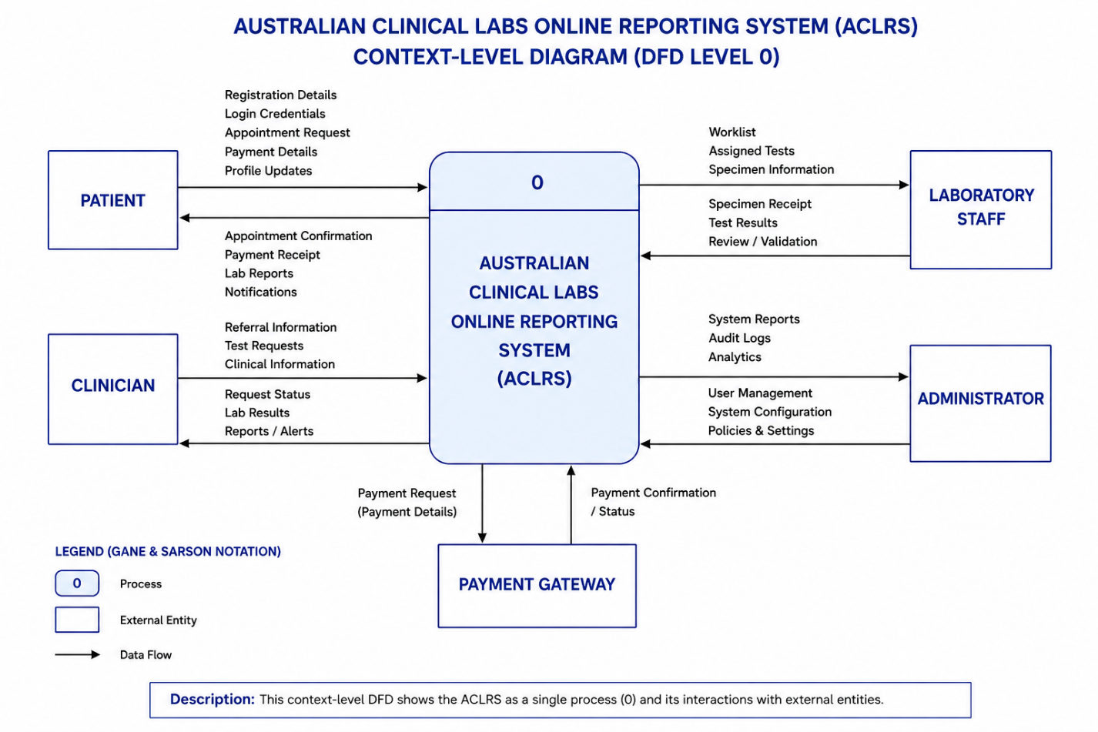

Figure: Context-Level Diagram (DFD Level 0)

Table: Explanation of the Context-Level Diagram (DFD Level 0)
Component | Description
ACLRS Process (0) | Shows the whole Australian Clinical Labs Online Reporting System as one main process that connects with all external entities.
Patient | Sends registration, login, appointment, payment, and profile details. Receives appointment confirmations, payment receipts, lab reports, and notifications.
Clinician | Sends referrals, test requests, and clinical information. Receives request status, lab results, and reports.
Laboratory Staff | Receives worklists and specimen information. Sends test results and validation details to the system.
Administrator | Manages user accounts, system settings, and policies. Receives reports, audit logs, and analytics.
Payment Gateway | Receives payment requests from the system and returns payment confirmation or payment status.
Data Flow | The arrows show how information moves between the external entities and the ACLRS.
Legend | Explains the Gane & Sarson notation used for the process, external entities, and data flows.
Overall Purpose | Gives a simple overview of how the main users and external systems interact with the ACLRS.

Table: Explanation of the Context-Level Diagram (DFD Level 0)

